Table of Contents

About SuperTyperTrainer: 1

# About SuperTyperTrainer:

The program will allow people to train to type faster. It will use a simple interface showing the layout of the keyboard towards the bottom of the screen and large, easy to read letters will move across the center of the screen. Initially, the letters will move slowly from right to left but gradually progress faster and faster as user becomes proficient in typing.

Screen Layout:

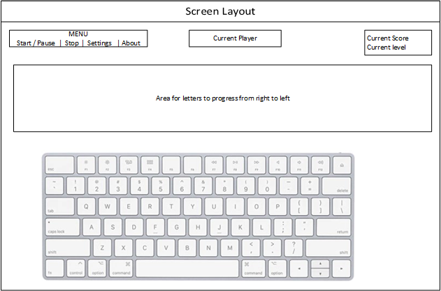

The first letter of the letter train will be highlighted in green background on the keyboard to help the person know where the keys are located. An incorrect key press will show in RED highlight and a short incorrect sound will play. If the correct key is pressed, a short correct sound will play.

Once the trainee has reached a certain level, the keyboard will disappear. Current player shown in the middle. Total score and current level will be displayed as well.

For the Menu:

Start button – Starts the sequence of letters and changes to Pause

Pause button – Pauses the sequence of letters and changes to Start

Stop button – Stops the sequence and resets the screen. Also saves all progress so far.

Settings button – Opens another screen that allows the user to change players and change current level.

About button – Opens a modal window that displays information about the program such as revision and programmers.